Module 2 - Learning Outdoor

IO1 – OUTSIDE Toolkit for Teachers

Session 2 - Learning outdoors in a traditional school

TEMPLATE 3

Varėnos r. Merkinės Vinco Krėvės gimnazij

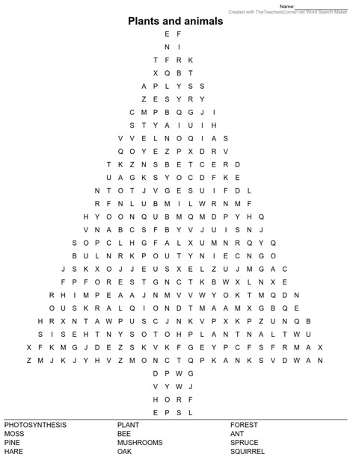
Find the hidden words related to nature

